The Setup

We'll be using the 'Learn Enough' tutorial series. The first one is here:

<https://www.learnenough.com/command-line-tutorial>

Since Windows does not have a Linux-like command line, you'll have to run a 'virtual machine' within Windows on your computer. I imagine that Ransom, you'll be using the home desktop, and Quintin, you'll be using your laptop. So you'll both have to do this initial setup.

The big picture is:

1. download and install VirtualBox (it's free)

2. download a virtual machine 'image' (provided by the tutorial, also free)

3. install the image in VirtualBox

Then, voila!, you'll have a Linux 'virtual machine' running inside of your Windows machine--like a computer within a computer.

Here are the details for the above steps:

**1. download and install VirtualBox (it's free)**

Go to:

<https://www.virtualbox.org/wiki/Downloads>

and click on 'Windows hosts' near the top of the page. This should start downloading as soon as you click it. (Mine took about 1 minute.) Download should show up at the bottom of your browser--click on it to start its installation wizard.

It may ask a few questions:

- something about disconnecting you from the network--that's fine

- may be a popup asking 'are you sure you want to install'--click 'yes'

Once it installs, should only take a few seconds.

**2. download a virtual machine 'image' (provided by the tutorial, also free)**

The link for this is in the first part of the tutorial. Go to 'Box 2' in the tutorial and click the link there where it says:

'2. Download the Learn Enough Virtual Machine (large file)'

It's a 2.5 GB file so it will take a while to download (mine took about 30 minutes)--so go get a snack while you wait.

**3. install the image in VirtualBox**

Once you've got the vm downloaded, double-click on it (it should be an 'ova' file. It will ask about changing settings--don't change anything for now. Just click 'import'--it should take about 1 minute.

Ok, you're almost there…

Now start up Virtual Box (there should be a shortcut on your desktop from the installation). It should look like this:

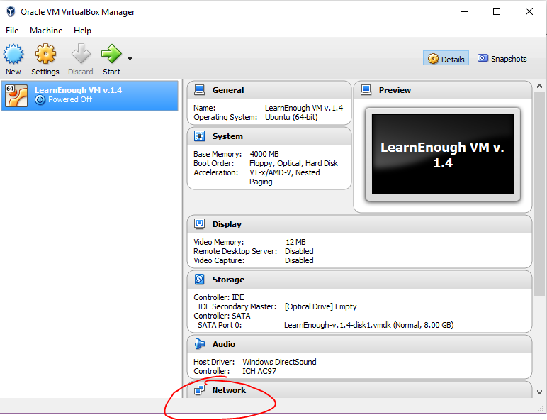

We need to tweak one setting regarding the network. Click on ‘Network’ and select ‘NAT’; then ‘OK’

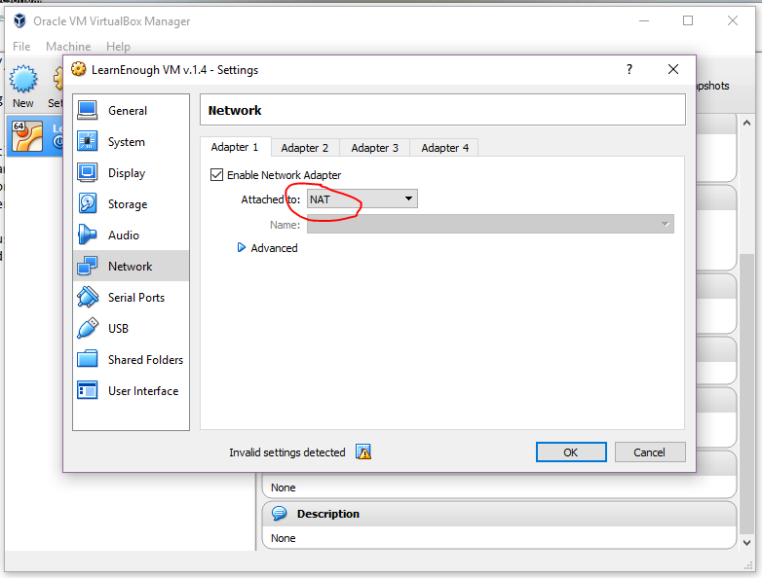

Then click 'Start' to boot up the virtual machine:

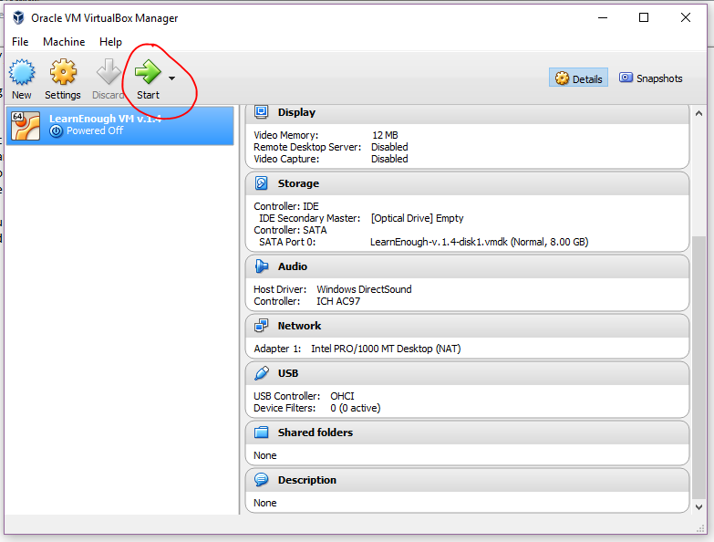

It will boot up Ubuntu Linux--you should see a screen like:

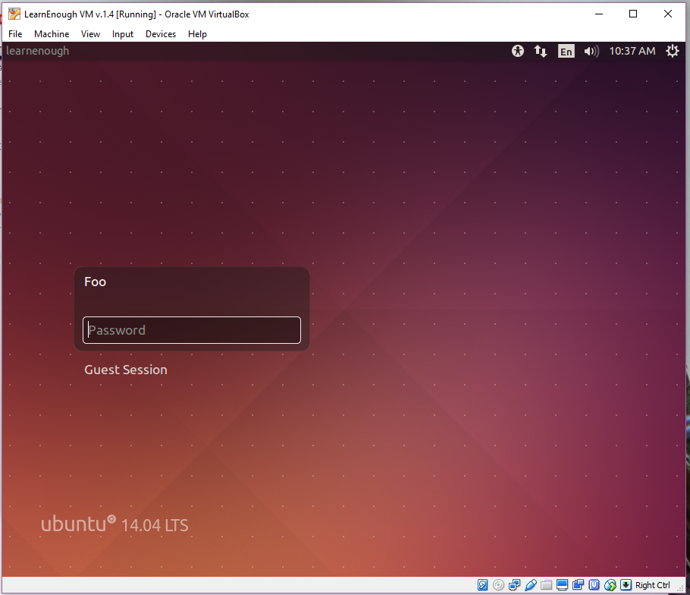

Use the password given in the tutorial (in Box 2).

There will be a couple of notification bars across the top—just click the ‘don’t show again’ buttons to get rid of them.

Now your Ubuntu desktop should look like:

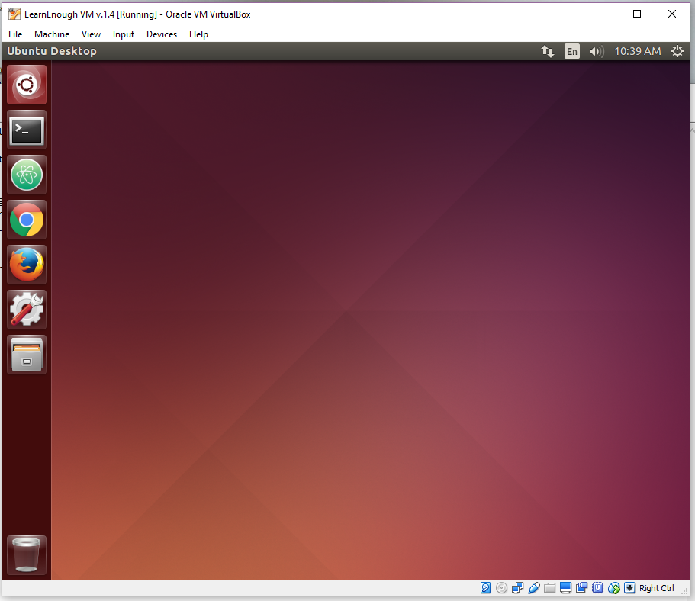

For shutting down the vm, the menu is in the upper right:

